Segment Addition Theorem
# Source: AI Source: Provided by: [Data Path: Persons Table -> ID Column: 1, Name_En Column: Motasem Essam] -> From: [ChatGPT] on [7/25/2026]
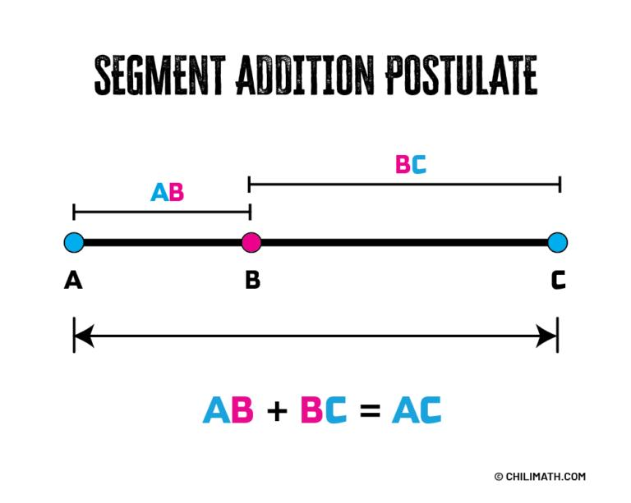
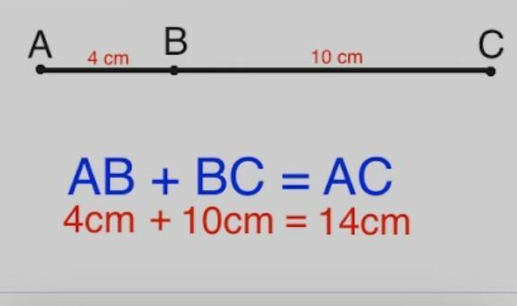​
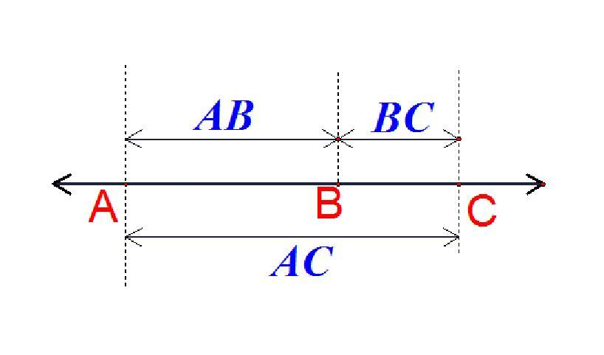​
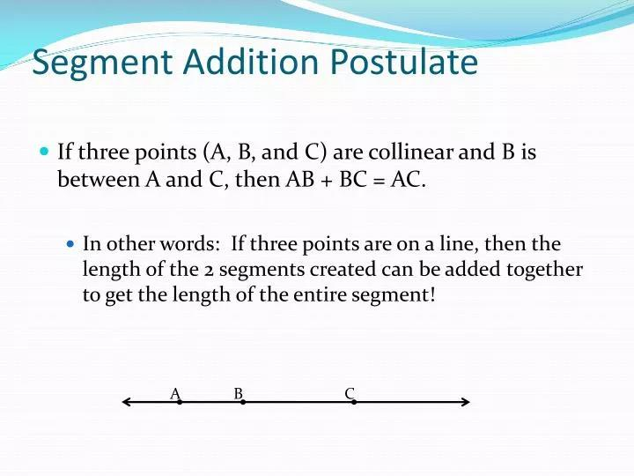

Definition
# Source: AI Source: Provided by: [Data Path: Persons Table -> ID Column: 1, Name_En Column: Motasem Essam] -> From: [ChatGPT] on [7/25/2026]
The Segment Addition Theorem states that:
If a point lies between the endpoints of a segment, then the lengths of the smaller segments add to the length of the whole segment.
For points $A$, $B$, and $C$, if $B$ lies between $A$ and $C$, then:
$$\boxed{AB+BC=AC}$$
Here:
- $AB$ → first part of the segment
- $BC$ → second part of the segment
- $AC$ → entire segment

Purpose
# Source: AI Source: Provided by: [Data Path: Persons Table -> ID Column: 1, Name_En Column: Motasem Essam] -> From: [ChatGPT] on [7/25/2026]
The Segment Addition Theorem is used to:
- Find an unknown segment length.
- Divide a segment into smaller parts.
- Verify relationships between collinear points.
- Solve geometric equations involving segment lengths.
- Determine distances between points on a line.

Basic Configuration
# Source: AI Source: Provided by: [Data Path: Persons Table -> ID Column: 1, Name_En Column: Motasem Essam] -> From: [ChatGPT] on [7/25/2026]
Suppose $A$, $B$, and $C$ are collinear, and $B$ is between $A$ and $C$:
$$A → B → C$$
Then:
$$AB+BC=AC$$
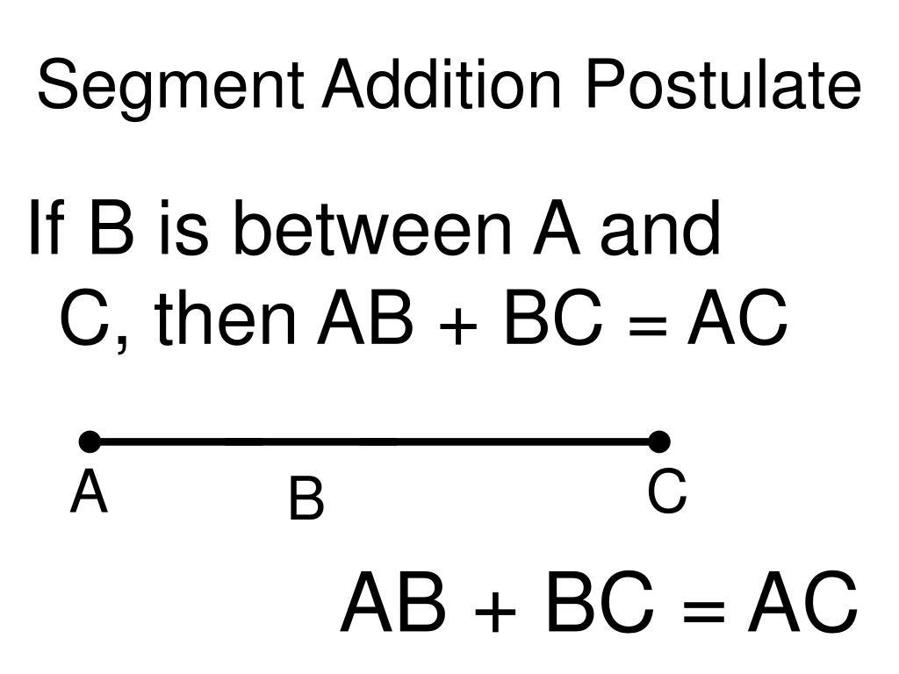​

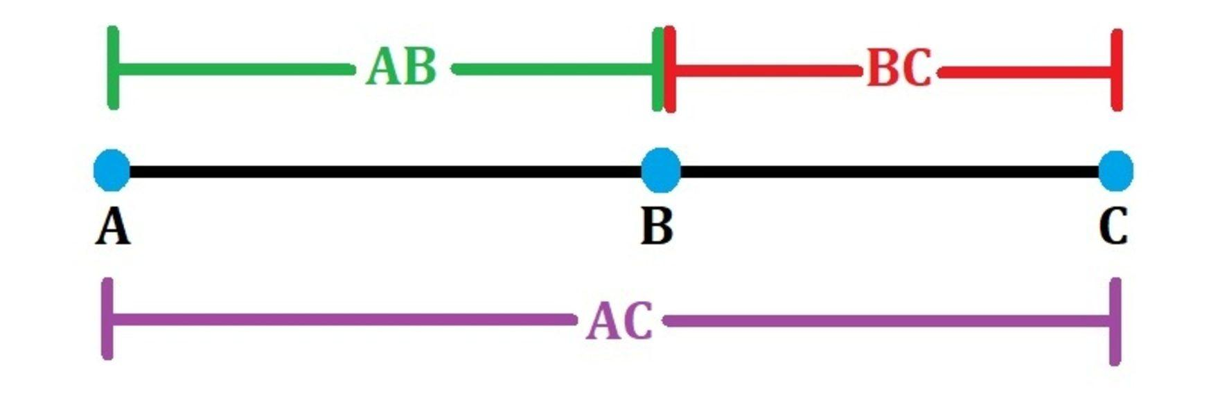

Important condition
# Source: AI Source: Provided by: [Data Path: Persons Table -> ID Column: 1, Name_En Column: Motasem Essam] -> From: [ChatGPT] on [7/25/2026]
The point must lie between the two endpoints.
For example, if:
$$A-B-C$$
then:
$$AB+BC=AC$$

Mathematical Representation
# Source: AI Source: Provided by: [Data Path: Persons Table -> ID Column: 1, Name_En Column: Motasem Essam] -> From: [ChatGPT] on [7/25/2026]
The fundamental formula is:
$$\boxed{AB+BC=AC}$$
From this, we can rearrange to find any unknown part:
$$\boxed{AB=AC-BC}$$
or
$$\boxed{BC=AC-AB}$$

Example 1 — Finding the Whole Segment
# Source: AI Source: Provided by: [Data Path: Persons Table -> ID Column: 1, Name_En Column: Motasem Essam] -> From: [ChatGPT] on [7/25/2026]
Suppose:
$$AB=5$$
and
$$BC=8$$
Find $AC$.
Using the Segment Addition Theorem:
$$AB+BC=AC$$
Substitute:
$$5+8=AC$$
Therefore:
$$\boxed{AC=13}$$

Example 2 — Finding a Missing Part
# Source: AI Source: Provided by: [Data Path: Persons Table -> ID Column: 1, Name_En Column: Motasem Essam] -> From: [ChatGPT] on [7/25/2026]
Suppose:
$$AC=20$$
and
$$AB=7$$
Find $BC$.
Start with:
$$AB+BC=AC$$
Substitute:
$$7+BC=20$$
Therefore:
$$BC=20-7$$
$$\boxed{BC=13}$$

Example 3 — Algebraic Segment Lengths
# Source: AI Source: Provided by: [Data Path: Persons Table -> ID Column: 1, Name_En Column: Motasem Essam] -> From: [ChatGPT] on [7/25/2026]
Suppose:
$$AB=2x+3$$
$$BC=x+4$$
and
$$AC=22$$
Using:
$$AB+BC=AC$$
we get:
$$(2x+3)+(x+4)=22$$
Simplify:
$$3x+7=22$$
$$3x=15$$
$$x=5$$
Now calculate the individual segments:
$$AB=2(5)+3=13$$
$$BC=5+4=9$$
Check:
$$13+9=22$$
Therefore:
$$\boxed{x=5}$$
and
$$\boxed{AB=13, BC=9}$$

More Than One Interior Point
# Source: AI Source: Provided by: [Data Path: Persons Table -> ID Column: 1, Name_En Column: Motasem Essam] -> From: [ChatGPT] on [7/25/2026]
The theorem can also be extended to several points.
Suppose:
$$A-B-C-D$$
Then:
$$\boxed{AB+BC+CD=AD}$$
For example:
$$AB=4, BC=6, CD=5$$
Then:
$$AD=4+6+5$$
$$\boxed{AD=15}$$
In general, if several consecutive segments form one larger segment:
$$\boxed{\text{Whole Segment}=\text{sum of all consecutive parts}}$$

Coordinate Geometry Connection
# Source: AI Source: Provided by: [Data Path: Persons Table -> ID Column: 1, Name_En Column: Motasem Essam] -> From: [ChatGPT] on [7/25/2026]
The Segment Addition Theorem is closely related to distance on a number line.
Suppose:
$$A=2, B=7, C=12$$
Then:
$$AB=|7-2|=5$$
$$BC=|12-7|=5$$
and:
$$AC=|12-2|=10$$
Therefore:
$$AB+BC=AC$$
$$5+5=10$$
So the theorem also works naturally with coordinate geometry.

Proof / Reasoning
# Source: AI Source: Provided by: [Data Path: Persons Table -> ID Column: 1, Name_En Column: Motasem Essam] -> From: [ChatGPT] on [7/25/2026]
Consider three collinear points:
$$A-B-C$$
The segment $AC$ consists exactly of two adjacent parts:
$$\overline{AB}$$
and
$$\overline{BC}$$
Since $B$ lies between $A$ and $C$, the two smaller segments do not overlap and together make the entire segment.
Therefore:
$$\boxed{AB+BC=AC}$$
This is sometimes called the Segment Addition Postulate rather than a theorem.

Relationship with Related Concepts
# Source: AI Source: Provided by: [Data Path: Persons Table -> ID Column: 1, Name_En Column: Motasem Essam] -> From: [ChatGPT] on [7/25/2026]
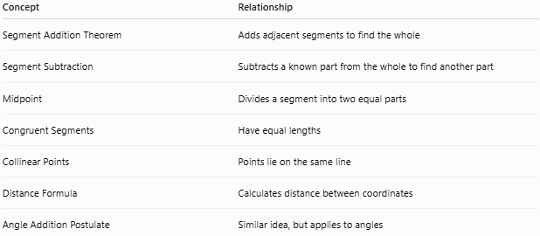
Concept | Relationship
Segment Addition Theorem | Adds adjacent segments to find the whole
Segment Subtraction | Subtracts a known part from the whole to find another part
Midpoint | Divides a segment into two equal parts
Congruent Segments | Have equal lengths
Collinear Points | Points lie on the same line
Distance Formula | Calculates distance between coordinates
Angle Addition Postulate | Similar idea, but applies to angles

Segment Addition vs. Angle Addition
# Source: AI Source: Provided by: [Data Path: Persons Table -> ID Column: 1, Name_En Column: Motasem Essam] -> From: [ChatGPT] on [7/25/2026]
There is a useful analogy:
Segment Addition:
$$AB+BC=AC$$
Angle Addition:
$$m∠ABC+m∠CBD=m∠ABD$$
Both use the idea that adjacent parts combine to form a whole.

Special Case: Midpoint
# Source: AI Source: Provided by: [Data Path: Persons Table -> ID Column: 1, Name_En Column: Motasem Essam] -> From: [ChatGPT] on [7/25/2026]
If $B$ is the midpoint of $\overline{AC}$, then:
$$AB=BC$$
Using the Segment Addition Theorem:
$$AB+BC=AC$$
Since $AB=BC$:
$$2AB=AC$$
Therefore:
$$\boxed{AB=BC=\frac{AC}{2}}$$
For example, if:
$$AC=18$$
then:
$$AB=BC=9$$

Applications
# Source: AI Source: Provided by: [Data Path: Persons Table -> ID Column: 1, Name_En Column: Motasem Essam] -> From: [ChatGPT] on [7/25/2026]
The Segment Addition Theorem is commonly used in:
- Geometry problems.
- Coordinate geometry.
- Number-line calculations.
- Construction and measurement.
- Engineering drawings.
- Architecture.
- Surveying.
- Finding distances between points.
- Solving algebraic geometry problems.

Common Mistakes

1. Adding the wrong segments
# Source: AI Source: Provided by: [Data Path: Persons Table -> ID Column: 1, Name_En Column: Motasem Essam] -> From: [ChatGPT] on [7/25/2026]
If:
$$A-B-C$$
the correct relationship is:
$$AB+BC=AC$$
not:
$$AB+AC=BC$$

2. Ignoring the order of points
# Source: AI Source: Provided by: [Data Path: Persons Table -> ID Column: 1, Name_En Column: Motasem Essam] -> From: [ChatGPT] on [7/25/2026]
The theorem requires the points to be arranged so that the middle point lies between the endpoints.

3. Confusing a segment with its length
# Source: AI Source: Provided by: [Data Path: Persons Table -> ID Column: 1, Name_En Column: Motasem Essam] -> From: [ChatGPT] on [7/25/2026]
Strictly:
$$\overline{AB}$$
represents the segment, while:
$$AB$$
usually represents its length.
Thus:
$$AB+BC=AC$$
is an equation about lengths.

Comparison with Related Concepts
# Source: AI Source: Provided by: [Data Path: Persons Table -> ID Column: 1, Name_En Column: Motasem Essam] -> From: [ChatGPT] on [7/25/2026]
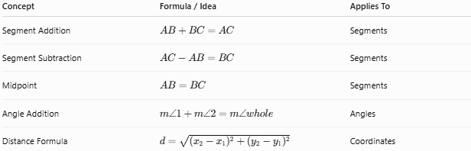
Concept | Formula / Idea | Applies To
Segment Addition | $AB+BC=AC$​ | Segments
Segment Subtraction | $AC-AB=BC$​ | Segments
Midpoint | $AB=BC$​ | Segments
Angle Addition | $m∠1+m∠2=m∠whole$​ | Angles
Distance Formula | $d=\sqrt{(x_{2}-x_{1})^{2}+(y_{2}-y_{1})^{2}}$​ | Coordinates

Key Points
# Source: AI Source: Provided by: [Data Path: Persons Table -> ID Column: 1, Name_En Column: Motasem Essam] -> From: [ChatGPT] on [7/25/2026]
- The Segment Addition Theorem combines smaller adjacent segments.
- If $B$ is between $A$ and $C$:
$$\boxed{AB+BC=AC}$$
- You can subtract a known part from the whole to find an unknown part.
- It requires collinear points with the middle point between the endpoints.
- It can be extended to multiple consecutive segments.
- It is closely related to the midpoint concept and distance on a number line.
- It is also commonly called the Segment Addition Postulate.

Conclusion
# Source: AI Source: Provided by: [Data Path: Persons Table -> ID Column: 1, Name_En Column: Motasem Essam] -> From: [ChatGPT] on [7/25/2026]
The Segment Addition Theorem provides a fundamental relationship between the parts and whole of a line segment. When a point divides a segment into adjacent parts, the lengths of those parts add to the length of the complete segment:
$$\boxed{AB+BC=AC}$$
It is one of the basic tools used throughout geometry for calculating unknown lengths and establishing relationships between points and segments.

